PriteePractical github Code

Admin@DESKTOP-C97TJQ7 MINGW64 ~/Desktop/Pritee (main)

$ git init

Initialized empty Git repository in C:/Users/Admin/Desktop/Pritee/.git/

Admin@DESKTOP-C97TJQ7 MINGW64 ~/Desktop/Pritee (master)

$ git status

On branch master

No commits yet

Untracked files:

(use "git add <file>..." to include in what will be committed)

abc.txt

nothing added to commit but untracked files present (use "git add" to track)

Admin@DESKTOP-C97TJQ7 MINGW64 ~/Desktop/Pritee (master)

$ git add .

Admin@DESKTOP-C97TJQ7 MINGW64 ~/Desktop/Pritee (master)

$ git status

On branch master

No commits yet

Changes to be committed:

(use "git rm --cached <file>..." to unstage)

new file: abc.txt

Admin@DESKTOP-C97TJQ7 MINGW64 ~/Desktop/Pritee (master)

$ git commit -m "first commit"

[master (root-commit) 87e0efd] first commit

1 file changed, 1 insertion(+)

create mode 100644 abc.txt

Admin@DESKTOP-C97TJQ7 MINGW64 ~/Desktop/Pritee (master)

$ git remote add origin https://github.com/Pritee2202/qwe.git

Admin@DESKTOP-C97TJQ7 MINGW64 ~/Desktop/Pritee (master)

$ git push origin master

Enumerating objects: 3, done.

Counting objects: 100% (3/3), done.

Writing objects: 100% (3/3), 220 bytes | 220.00 KiB/s, done.

Total 3 (delta 0), reused 0 (delta 0), pack-reused 0

To https://github.com/Pritee2202/qwe.git

\* [new branch] master -> master

Admin@DESKTOP-C97TJQ7 MINGW64 ~/Desktop/Pritee (master)

$

Output

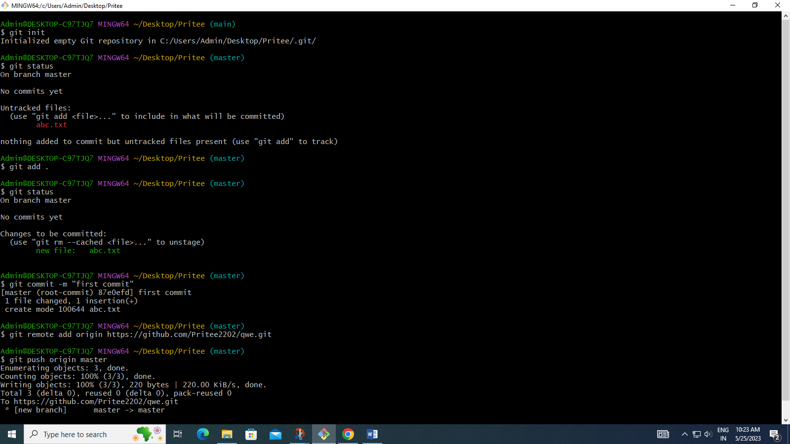

Github pushed file output

